

EARTHQUAKE PREDICTION MODEL USING PYTHON

PHASE 3 : DEVELOPMENT PART 2

PROJECT MEMBERS :

* ABIKASH .P - au61072112101
* AJITH KUMAR .T - au61072112102
* DEIVENDRAN.B - au61072112110
* EZHIL ARASAN .S - au61072112115
* THIRUMALAI .R - au61072112147

EARTHQUAKE PREDICTION MODEL USING PYTHON :

POINT 3: DEVELOPMENT PART 2

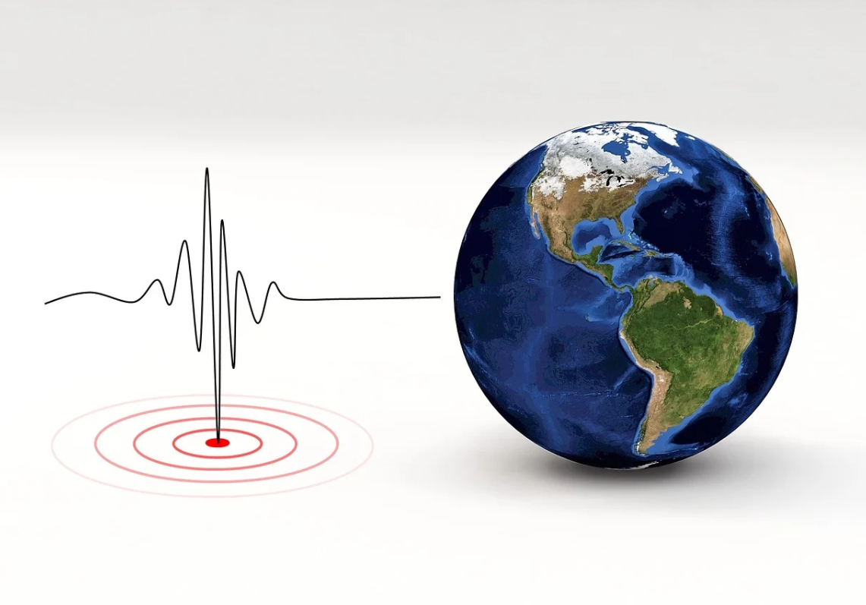

**Real-Time Data Acquisition**:

To build an early warning system, you'll need real-time data from seismometers and other sensors. You may need to work with seismological organizations or institutions for access.

**Machine Learning and Modelling**:

Employ advanced machine learning techniques, such as deep learning, to build predictive models. Some approaches include Recurrent Neural Networks (RNNs), Long Short-Term Memory (LSTM) networks, and Convolutional Neural Networks (CNNs). These models can be used for time series analysis and forecasting.

**Data Fusion**:

Combine seismic data with other sources like weather data, ground deformation data, and satellite imagery to improve the accuracy of predictions.

**Early Warning System**:

If you are building an early warning system, consider real-time alerting mechanisms, such as SMS, mobile apps, or sirens, to inform people in the affected areas.

**Model Evaluation**:

Use appropriate evaluation metrics for your specific task, such as Receiver Operating Characteristic (ROC) curves, False Alarm Rate (FAR), and Probability of Detection (POD).

**Continuous Improvement**:

Continuously update your model as new data becomes available and as you refine your algorithms. Collaborate with domain experts in seismology to improve your predictions.

**Legal and Ethical Considerations**:

Ensure that you comply with legal and ethical guidelines regarding data collection, sharing, and public alerts.